**2022年中国政府奖学金年度评审系统操作步骤（学生版）**

**2022 Chinese Government Scholarship Annual Review System Operation Steps (Student Version)**

1. 参评学生打开中国政府奖学金生来华留学管理信息系统<https://studyinchina.csc.edu.cn/?9FyBl6JDFLTe=1649809886884#/login>，右上角选择中文或者英文界面，并点击【CSC登记号登录】，登录至信息系统；
2. Students who should participate in the Annual Review please open the management information system for CSC through this link <https://studyinchina.csc.edu.cn/?9FyBl6JDFLTe=1649809886884#/login>. Then click 【CSC Number】, and log in to the system;

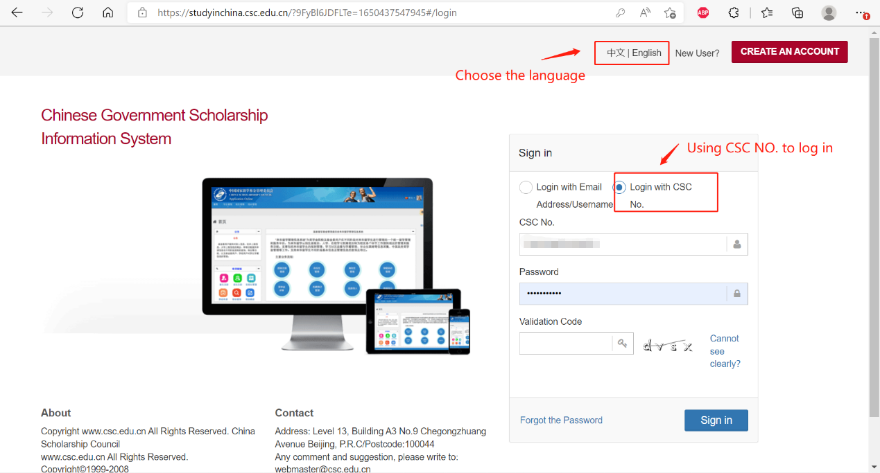

1. 选择【奖学金年度自评】；
2. Select【Annual Review of scholarship】;

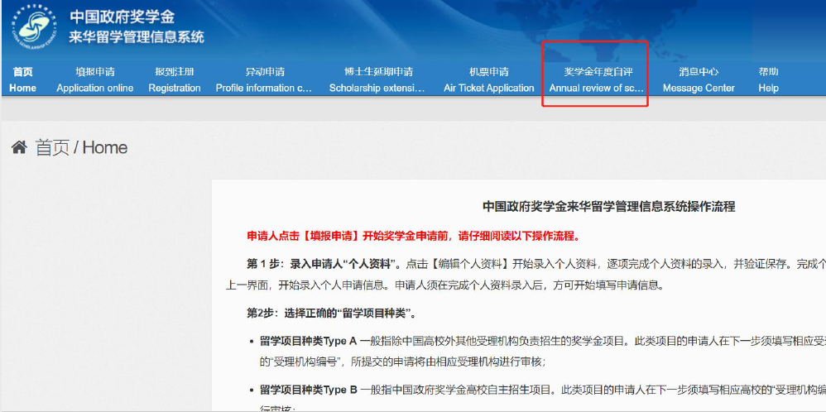

1. 进入自评页面，完成“中国政府奖学金院校评估问卷”。注意，如果不完成该问卷，将无法开始奖学金自评内容的填写。
2. Go to the self-assessment page and complete the "Chinese Government Scholarship Evaluation Questionnaire". Note: if you do not complete the questionnaire, you will not be able to start filling out the scholarship self-assessment.

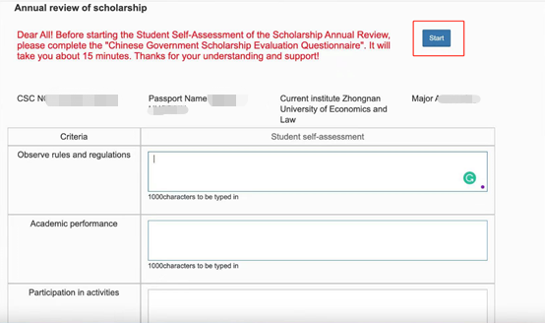

1. 参评学生从遵规守纪、学习情况、参加活动情况三个方面，对自己过去一学年的在校表现进行评价。遵规守纪方面，可填写自己过去一年是否遵守了中国国家法律、在校管理规定、是否按时参加奖学金签到，是否尊重老师；学习情况方面，可描述自己过去一学年的加权平均成绩、科研态度、论文发表情况等；参加活动情况方面，可列出过去一学年参加的校内外各项活动。并在【添加附件】处上传学习成绩单、获奖证书等附件材料。
2. Students will evaluate their school performance in the 2021-2022 academic year from three aspects: Compliance, Learning, and Participation in Activities. In terms of Compliance, you can fill in whether you have complied with Chinese national laws, school management regulations, whether you have signed on time for every month and respect for teachers, etc.; in terms of Learning, you can describe your weighted average grades, scientific research attitude, and paper publications etc. in the past academic year; in terms of Participation in Activities, you can list various activities on and off campus that you have participated in in the past academic year, or the honors you have won in this academic year. And upload the academic transcripts, award certificates and other attached materials in the [Add].

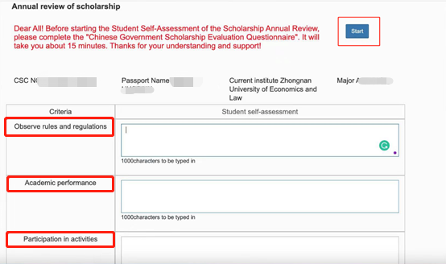

1. 填写完成并上传附件后，勾选承诺条款，点击提交。
2. After filling in and uploading the attachments, check the terms of commitment and click Submit.

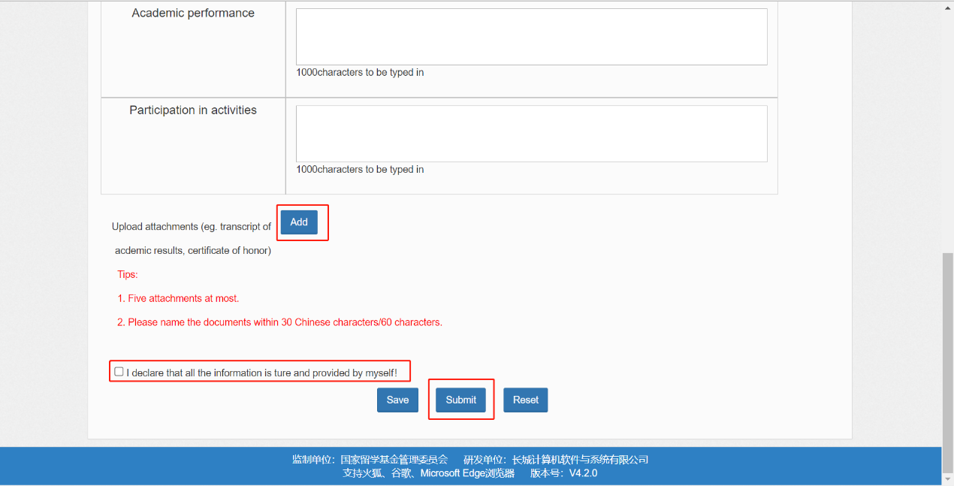

1. 学生完成自评，提交后的页面如下：
2. Complete self-assessment, the submitted page is as follows:

