Guidelines for Applying for Electric Bicycle Campus License Plate

- Enter to the WeCom app from Zhongnan University of Economics and Law
- Enter the Workspace
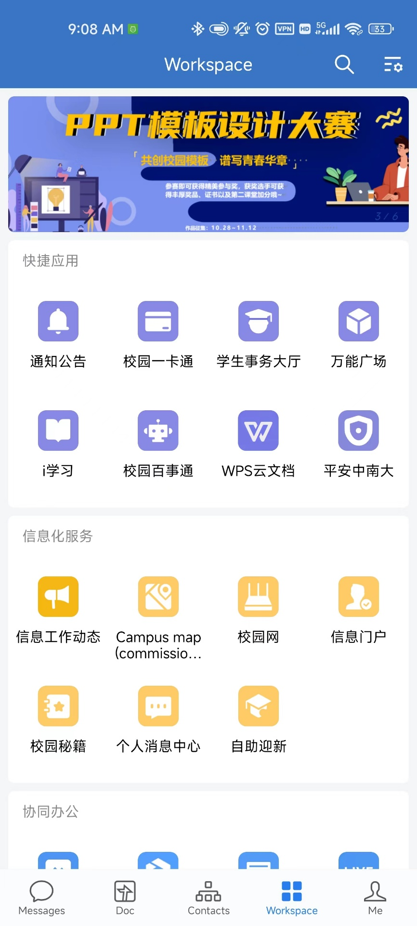

- Enter to 平安中南大

- Then enter to 电动自行车校内牌办理 (Application for Electric Bicycle Campus License Plate)
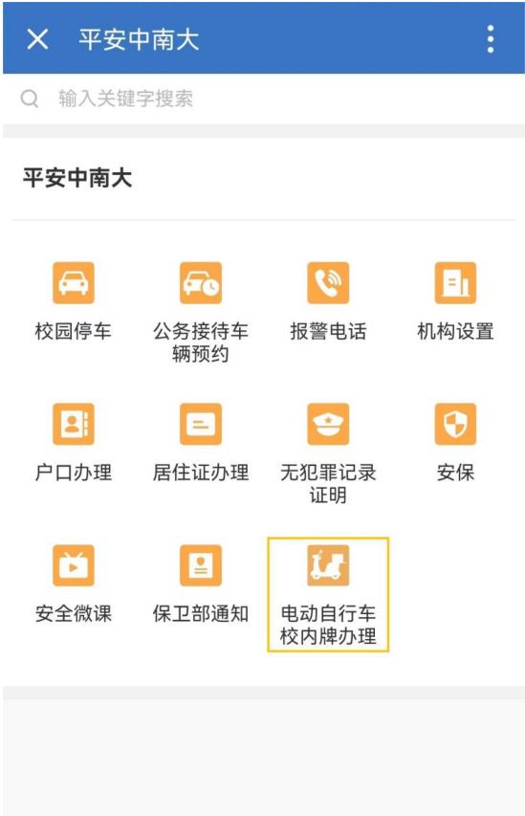

- For those who have a Wuhan license plate, click on 已办理武汉牌照 (Wuhan License Plate has been processed) and fill in and upload relevant information as required (if the applicant is a student, the graduation time must also be filled in). After filling in and uploading, click on 申请 (Apply).
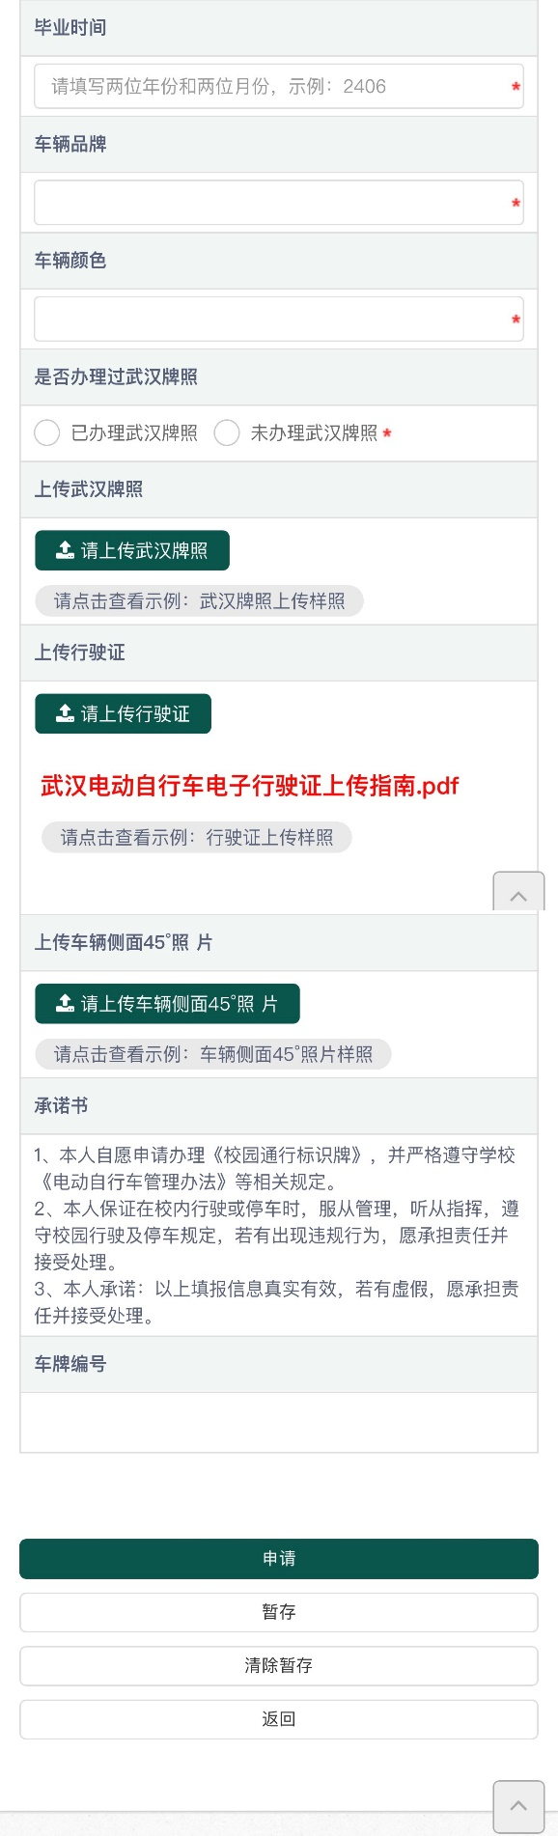
Graduation time
Apply
Bike’s color
Bike’s brand
Upload a 45° photo of the side of the bike
You can click to view “Wuhan Electric Bicycle Electronic Driving license upload guide.docx”
Upload the Wuhan license plate
Upload Driving license
- For those who do not have a Wuhan license plate, click on 未办理武汉牌照 (Did not apply for Wuhan license plate) and fill in and upload relevant information as required (if the applicant is a student, the graduation date must also be filled in). After filling in and uploading, click on 'Apply'.

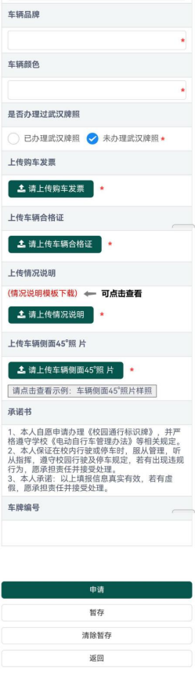
Apply
Upload a 45° photo of the side of the bike
Upload bike’s Purchase invoice
Upload bike’s Qualification certificate
Upload the Description of the situation
Bike’s color
Bike’s brand

- Applicants can check the progress of the application process on 办理流程.

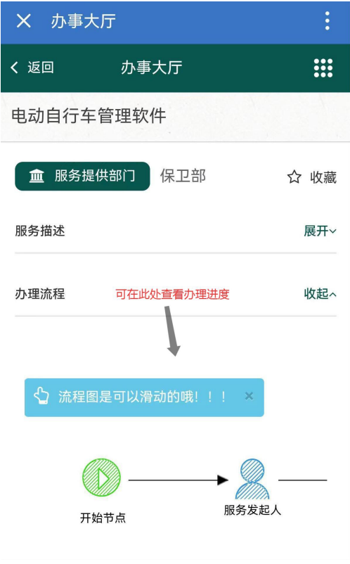
You can view the progress of the application process here

